Title | VLO server benchmark
Version | 1
Author(s) | Willem Elbers, Dieter Van Uytvanck
Date | 2015-06-25
Status | Final version - informative
Distribution | centre committee
ID | CE-2015-0555

Introduction
CLARIN is currently in the process of migrating services from the MPI hosted catalog.clarin.eu to other (virtual) servers, possibly provided by commercial providers.

One of the applications in this migration is the importer of the Virtual Language Observatory (VLO). This is a process which typically takes a long time to run.

To find a suitable new home for the VLO we decided to compare a number of Virtual Private Server (VPS) providers, both from the academic and the commercial domain. The results of this comparison are presented in the remainder of this document.

Please note that we see this benchmark just a tool to make a good selection, not a goal by itself. Therefore a deeper analysis of performance differences is purposefully not included here.

Machine Details
 | Macbook Pro | HostEurope | CESNET | 100%IT | TransIP
Country |  | DE (commercial) | CZ | UK | NL  (commercial)
CPU | i5  @ 2.6 GHz | Xeon  E5-2620 v3  @ 2.40GHz | Xeon  E5-2650 v2  @ 2.60GHz | Xeon X5670 | Westmere E56xx/L56xx/X56xx
vCores | 4 | 8 | 8 | 8 | 8
Mem (GB) | 16 | 16 | 32 | 32 | 16
Disk | SSD | SSD | HDD | SSD | SSD
File System | HFS+ | EXT4 | EXT3 | XFS | XFS
Virtualisation environment | none | Virtuozzo | OpenNebula  (KVM) | VMware(?) | KVM

To place the results in a wider context we have included a Macbook Pro (Retina, 13-inch, Late 2013, OS X 10.9.5) in the test. All other tests were performed under CentOS Linux (7.0 or 7.1).

Benchmark results

Realistic full-scale test – VLO import

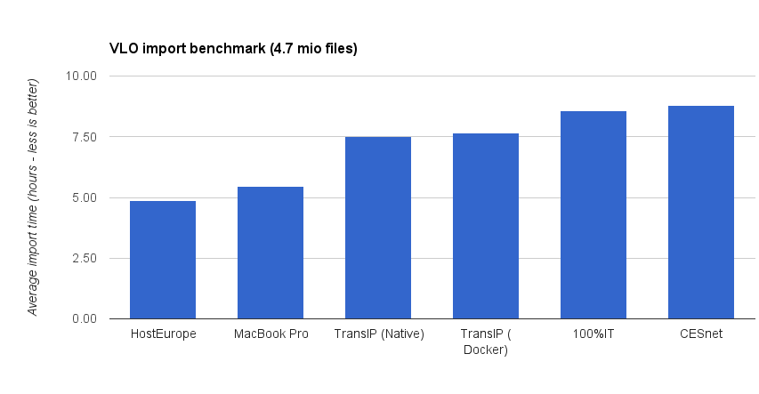

Realistic Disk IO test – Untar operation

Artificial test – Random disk I/O

Artificial test – CPU performance

Realistic test – download speed

Summary

- Based on the raw numbers of the realistic tests, the HostEurope VPS is the best performing option.
- Interestingly enough, the MacBook Pro outperforms all other servers for the VLO importer task.
- A surprising result for us was the difference between providers offering SSD based storage. The faster providers reaches 270+ MiB/s with random read/write operations while others only reach 17 MiB/s and 6 MiB/s.

Appendix: benchmark details

We have run two benchmarks on each system to get insight in general performance and vlo harvester specific performance.

Artificial test: sysbench

The sysbench test suite has been used to gather some quick insights in general system performance. On each system we ran both a single and multithreaded prime test together with a random read/write test to give some insight in general performance and disk I/O.

Single threaded prime numbers, sb-prime-st:
sysbench \
--test=cpu \
--cpu-max-prime=20000 run

Multi threaded prime numbers, sb-prime-mt:
sysbench \
--test=cpu \
--cpu-max-prime=20000 \
--num-threads=8 run

Random read/write, sb-random-rw:
sysbench \
--test=fileio \
--file-total-size=150G \
--file-test-mode=rndrw \
--init-rng=on \
--max-time=300 \
--max-requests=0 run

Before this test 128 files, totaling to 150 GB, were written to the disk:

sysbench --test=fileio --file-total-size=150G prepare

Realistic test: vlo-benchmark
To test the VLO importing process a benchmark suite, published on GitHub, has been prepared. The test suite comes with a bundled Tomcat server running Solr 4.8. The Tomcat process must be running during the harvesting.

A test dataset, ~4.7 million records totalling around ~31 GiB, has been made available via the EUDAT B2DROP service.

The VLO importer is an application that reads in metadata files (CMDI XML), parses them and then ingests the documents in the SOLR deamon. It is multi-threaded (in the tests at least 3 threads were active: 1 for the parser and 2 for communication with SOLR) but can still be optimized (the parsing process itself is currently single-threaded). This is planned for future versions of the VLO importer.
For the actual benchmark it is assumed that the dataset is available. The download and extraction of the bzip2 archive are not included in the benchmark timings.

 | # samples | Running time (hours)
 |  | MIN. | MAX. | AVG.
HostEurope | 11 | 4,82 | 4,94 | 4,87
CESnet | 2 | 8,61 | 8,97 | 8,79
TransIP | 6 | 7,36 | 7,61 | 7,50
Macbook Pro | 1 | - | - | 5,47
100% IT (UK)** | 1 | - | - | 8,50

Realistic test: downloading the tarball

In this test we measured how long it takes to download a single file of 689 MB from the EUDAT B2DROP server situated at FZJ in Jülich, Germany:

time wget --no-check-certificate 'https://b2drop.eudat.eu/public.php?service=files&t=a3e18f04e900fab527e4af3727524f55&download&path='

Although this estimation of the downstream bandwith obviously depends on the location of the server, it is a realistic measure as many CLARIN servers are currently situated in Germany and the Netherlands.

Realistic test: untarring

In this test we measured how long it takes to unpack a tarball containing the 4.7 million CMDI files.

nohup time tar xvf vlo-benchmark-data.tar &

Final notes
As the VM from HostEurope is clearly outperforming all other providers for the most realistic benchmark (VLO importer) at a relatively low cost (50 EUR/month) we plan to migrate the harvester and VLO to this provider.

CESNET prove to be very responsive and service-minded during the benchmark phase. This makes it a suitable candidate for the future hosting of other services (component registry, nexus and docker repository).

CPUs as reported by /proc/cpuinfo – in virtual environments this can differ from the reality
In order to find out the influence of the file system we replicated the untar benchmark and the random disk I/O test with an EXT4 system on the same host (running Ubuntu 14.04). No significant difference was found.
See https://github.com/akopytov/sysbench
See https://github.com/TheLanguageArchive/vlo-benchmark
See https://b2drop.eudat.eu/public.php?service=files&t=a3e18f04e900fab527e4af3727524f55
http://vtd-xml.sourceforge.net/
http://lucene.apache.org/solr/4_2_1/solr-solrj/org/apache/solr/client/solrj/impl/ConcurrentUpdateSolrServer.html
See http://www.fz-juelich.de

